# Automatic SEM Processing

Scanning Electron Microscopy paired with Energy Dispersive Spectroscopy (SEM/EDS) images enable high magnification analysis of a sample’s morphology and chemical composition. The analysis of SEM/EDS images often involves comparing multiple scans at the same time. In my case, I wanted to compare the results of 5 different samples over 5 time-steps, with each time step having upwards of 10 scans each (**>250 scans!**). I chose to organize this data into an **automatically generated PowerPoint presentation** since each image set (SEM image + elemental maps) can be grouped into a slide, and each imaging session grouped into a PowerPoint presentation. The data is also usually directly presented in PowerPoints, so this conversion also saves time making slides.

When running the script, the directory containing all the scans is given as input, and the subdirectories containing each scan are iterated to generate individual slides. There are four imaging modes, and each should be laid out differently. Example generated slides for each are shown below. The map, region, and spot analysis modes all are processed similarly, with a barplot of the total composition generated and all the data neatly laid out on the slide.

The linescan imaging mode takes more processing. This mode enables the elemental composition to be tracked over a line. The main benefit of this mode is the ability to see the quantitative breakdown of the composition, which is not easily displayed in a map scan. The line may be at any angle and length, so a **Hough Transform** is used to identify where the linescan is and the direction of the arrow, then the image is cropped and rotated so the scan can be read left to right. The cropped images are then displayed alongside a plot of the composition.









## Image Cropping

The magnification of SEM/EDS images may not all the be same sample-to-sample, so in order to compare them, we would like to crop them to all the same scale so sizes may be compared. A list of scans can be uploaded to this script, and in each:

1. The scale bar is identified, and the user is prompted to input the length of the scale bar. The program automatically counts the pixel length to determine the proper scale



1. The user-defined window dimensions is overlayed over the SEM image and corresponding EDS images to indicate the cropping area.

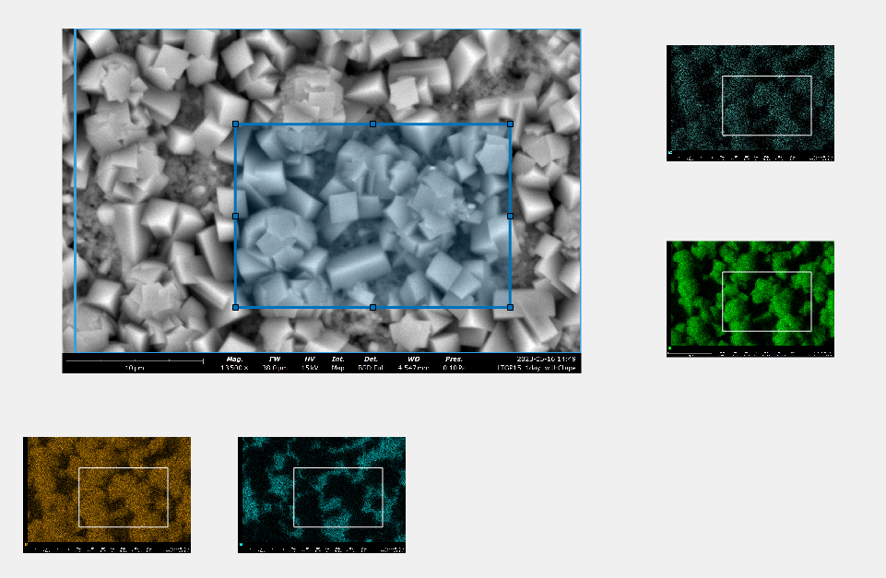

One improvement may be to use OCR (optical character recognition) to read the scalebar and determine the scalebar automatically. I decided against this because the prompt to enter the length of the scalebar also serves as a way for the user to check that the program is properly identifying the length of the scalebar. Although my method for scalebar identification has been very reliable so far, it is nice to keep track of exactly what the program is doing, especially since these images will be used for publications and presentations.